Directions to Oakside House Clinic Google map link: 35 Oakfield Rd
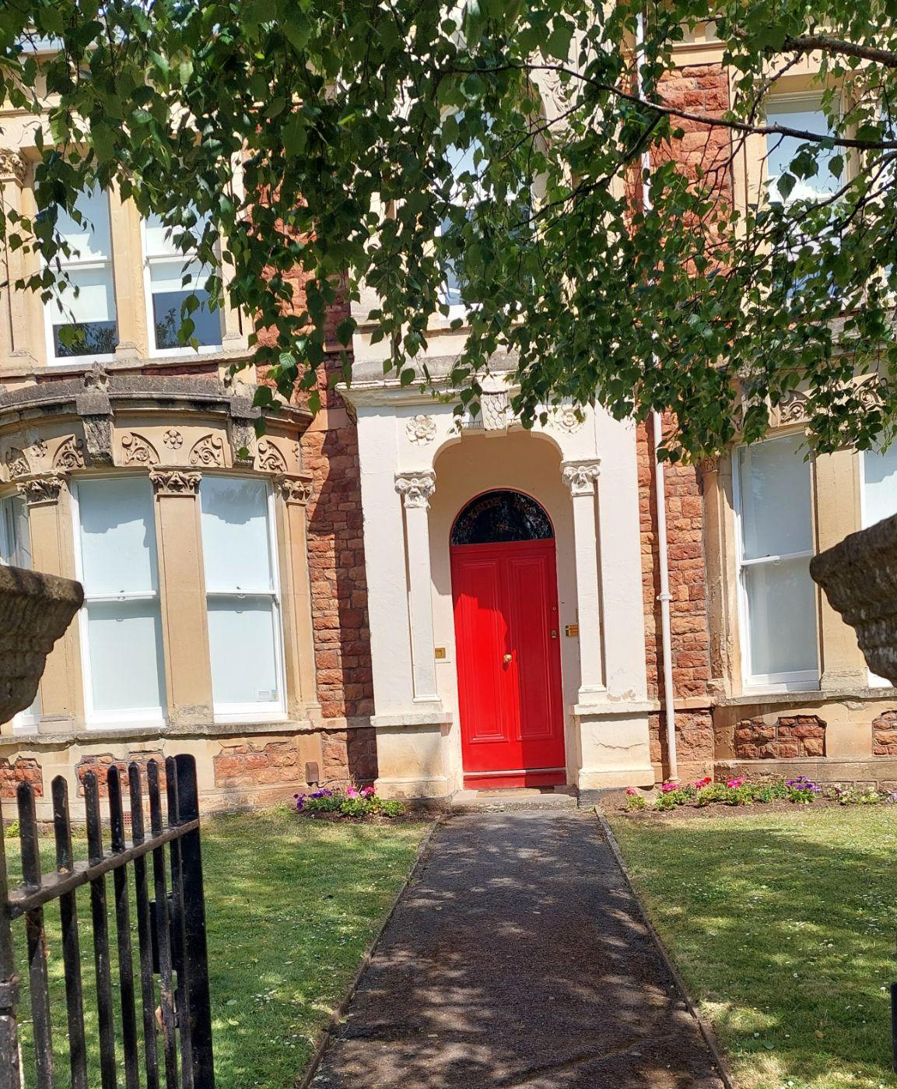

Our new clinic space is at Oakside House, 35 Oakfield Road, Clifton, Bristol BS8 2AT.

Getting there

We are a 5 minute walk from bus stops on Whiteladies Road and 10 minutes walk from Clifton Down train station.

If driving, there is limited on-street metered car parking available for up to 3-4 hours on Oakfield Road and on local surrounding roads. This is managed by RingGo. There is also a large car park at Clifton Down Shopping Centre, which is a 10 minute walk from Oakside House. The entrance to the car park is on 93 Alma Road BS8 2NN. (Up to two hours is free if you spend £20 in Sainsbury’s and get the token validated in the store. Otherwise, the charge is £1.50 up to an hour, £2.50 up to two hours etc.) Unfortunately the car park at the back of our building is private and not available.

Arrival

We are the building which borders the corner of Leigh Road, with a red door and the bright rhino sculpture in the garden! When you arrive at the time of your appointment, please press the buzzer which corresponds with the room your session is being held in i.e. Bristol CBT Clinic 1 or Clinic 2. Your doctor/therapist will release the front door and/or meet you at the entrance. If you are buzzed in or a little early, there is a waiting area straight ahead. There are toilets but please bring your own drink if needed.

Should you have any questions at all, please contact Lesley on info@piamenzies.com or 01454 854492.

